USER DOCUMENTATION

**In this document we are going to learn how to display all records of MYSQL through java program.**

**Note to display data from MYSQL table, there needs to be at least one row of data available.**

**You need to have MYSQL database installed**

[**https://www.mysql.com/downloads/**](https://www.mysql.com/downloads/)

**To connect to MySQL from Java, you have to use the JDBC driver from MySQL. The MySQL JDBC driver is called MySQL Connector/J. You find the latest MySQL JDBC driver under the following URL:**[**http://dev.mysql.com/downloads/connector/j**](http://dev.mysql.com/downloads/connector/j)**.**

**The download contains a JAR file**

**As explained above, to be able to connect to a MySQL database, you need the JDBC driver for MySQL. This is called the Connector/J driver and can be downloaded from**[**the MySQL site here.**](https://dev.mysql.com/downloads/connector/j/5.1.html)

**Once you download the ZIP (or TAR.GZ) file, extract the archive and copy the JAR file mysql-connector-java–bin.jarto a suitable location. This file is required for running any code that uses the MySQL JDBC Driver.**

**Assuming you have downloaded the MySQL database and**[**set it up properly**](https://www.makeuseof.com/tag/install-mysql-windows/)**where you have access to it, let us create a sample database so we can use it for connecting and performing queries.**

**Connect to the database using a client of your choice and run the following statements to create a sample database.**

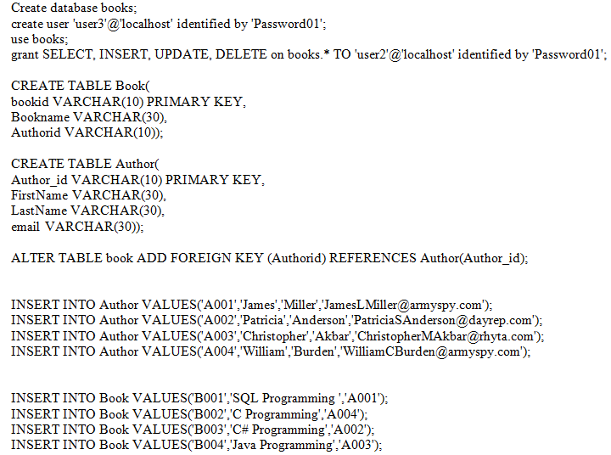

**Now that we have a Database for MySQL driver from java, let us get connecting to the database.**

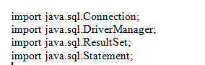

**Enter this at the start for the connection to MYSQL to JAVA**

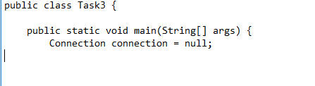

**Next add your public class and also public static void main with**

**Connection connection =null**

**Now To connect the whole thing together. (NOTE this is just a quick sample)**

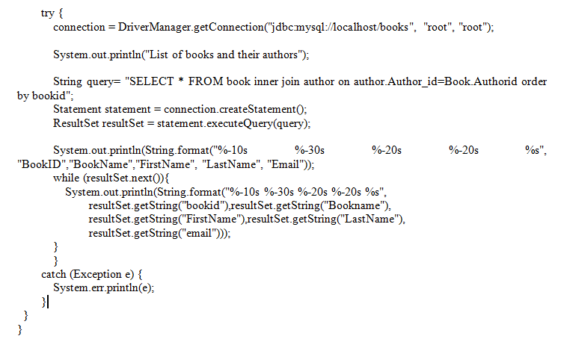

**THE OUTPUT WILL DISPLAY AS FOLLOW**

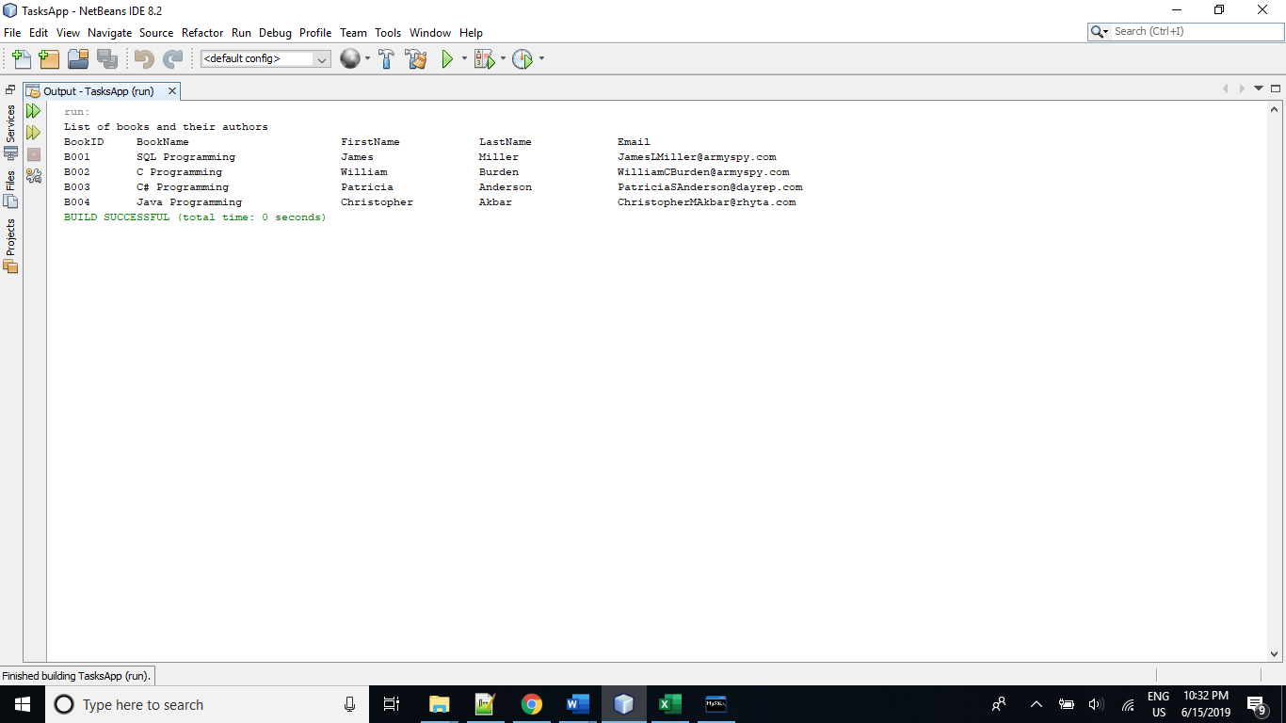

**WHAT YOU SHOULD NEVER DO IS HAVE MULTIPLE FILES OF THE JAVA FILE IN DIFFERENT LOCATIONS ON YOUR COMPUTER ALWAYS STICK TO ONE FILE.  
REMEMBER TO HAVE THE JBDC DRIVER INSTALLED OR IMPORTED IN ORDER TO HAVE THEM COMMUNICATNG TO EACH OTHER.**

**Don't use Access as an embedded database. Not even Microsoft recommends using it for that purpose these days. Microsoft recommends using SQL CE as an embedded database.**